MONICA RUSSELL

Contact no: 0430 173 340

Email: monandnick@yahoo.com

IMDB: http://www.imdb.com/name/nm3752320/

Personal Details

D.O.B. : 24/08/1981 Place of birth: Sydney

Playing Age: 33-43 yrs Size: 8

Height: 5’4’’ Eyes: Brown

Hair: Black Build: Slim

Ethnicity: Chinese

Languages: English, Cantonese (basic)

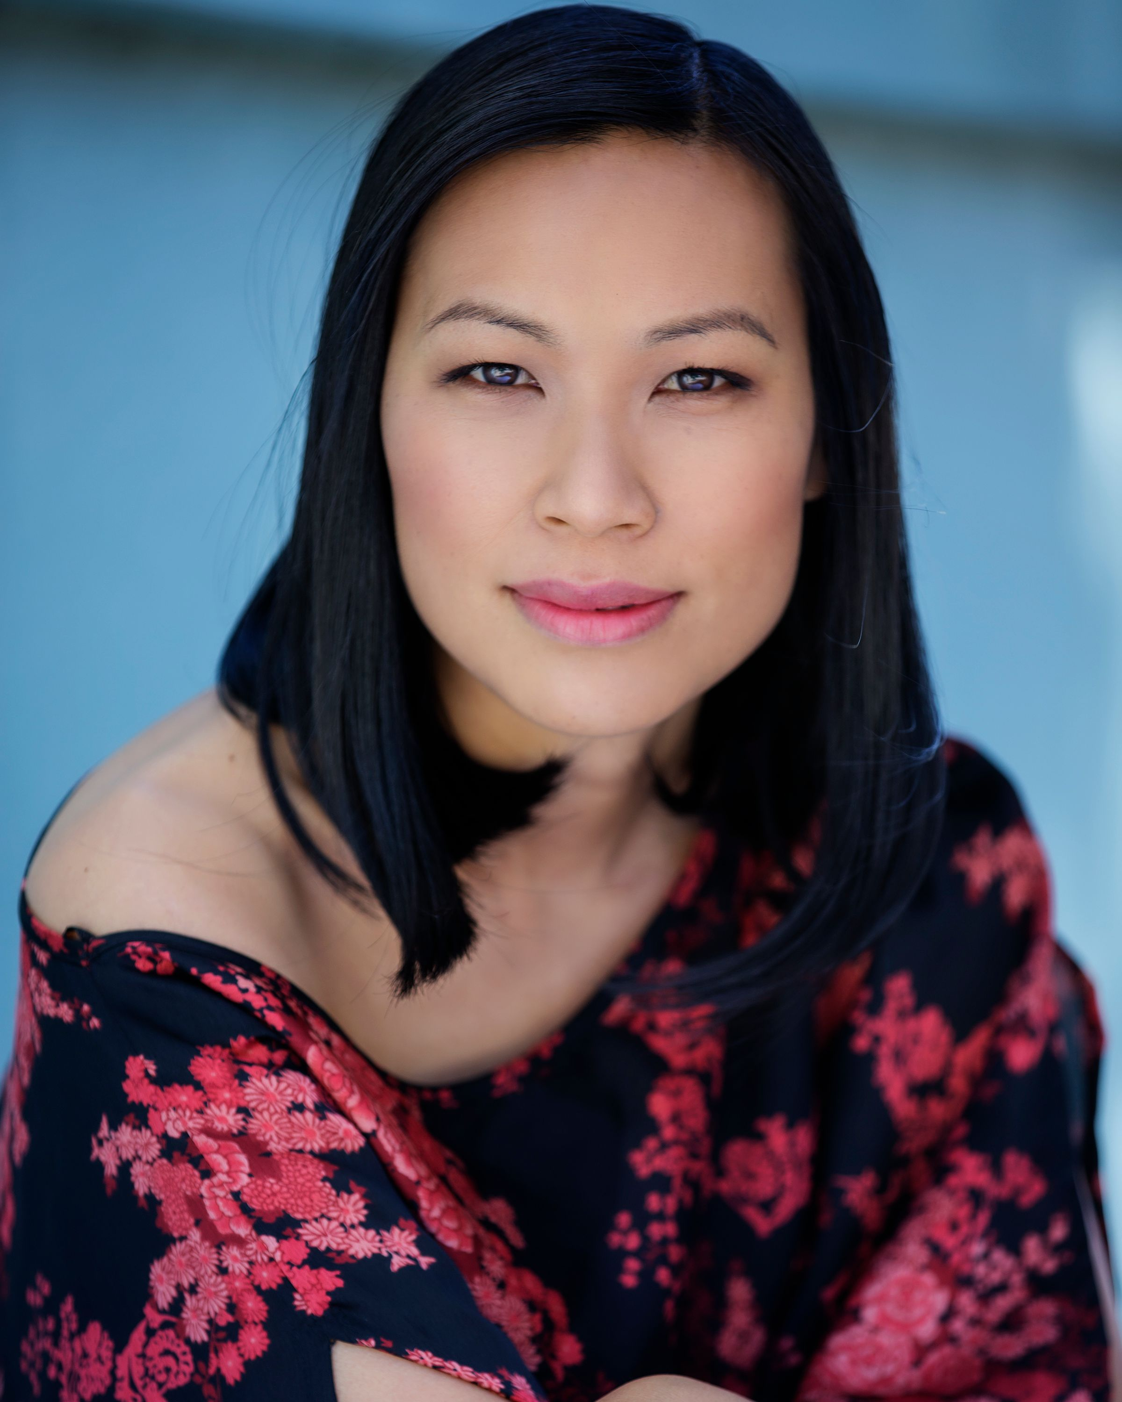

Skills

Piano (Diplomas: A.Mus A, L.Mus A, ATCL, Performers Certificate), Violin (Grade 8), Guitar, Bachelor of Economics (Honours), Driving license (car), Horse riding, Swimming, Cooking, Television presenting, VJing, Mum to 3 kids

Training
2009  2009  2009 | Advanced screen acting course  Comedy course  Private acting lessons (Chubbuck technique) | Screenwise  The Actors Centre  Anthony Wong
2008  2008 | Intermediate screen acting course  Television Presenting course | Screenwise  Sydney Academy of Film and Television
2008-2009 | Method acting classes (Meisner technique) | The Actors Studio
1994-1999 | Improvisation and scenework for theatre | Australian Theatre for Young People

Film

Year  2020  2020  2010 | Role  Kylie Yun (support)  Mum (support)  Lian (lead) | Production  Risen  At The End Of The Day  China Heart | Director  Eddie Arya  Michelle Jasan  Annette Shun Wah | Company  Aryavision Productions  Discount TV  Fish Productions
2009  2009 | Jade (lead)  The Dealer (support) | The Cure  The Poker Game | Sky Meng  Andrew Rakuljic | College of Fine Arts  North Sydney TAFE
2008 | Chinglin (support) | The Doppleganger | Karl Emmett | College of Fine Arts
2008 | Ava (lead) | Winding Road | Gareth James | Dynsopic Productions
2008 | Elise (support) | Pictures of Anna | Andrea Oliva | Macquarie University

Television/Corporate Videos/Other

Year  2021  2021  2020  2020  2018  2017  2016  2016  2015  2015  2015  2015  2015  2013  2012  2009  2009 | Role  Voiceover  Voiceover  Manager  Commuter  Digital Specialist  Mother  Doctor  Ms Lee  Wife/Mother/Voiceover  Presenter  Presenter  Party Host/Mother  Patient  Mother  Bank Customer  Chindogu  Zoe | Production  Nine Step Negativity Detox  Woolworths Training Video  Ranstad  St Marys Town Centre  Westpac  WAHPA  HETI eLearning  Rode Microphones  Cochlear  Career HQ  Open Learning  ZIP Industries  Sovanapoom Care  Baxter  CBA TV  The New Inventors  The Suspects Episode 3 | Director  Bill Dowling  Angus Stevens  Glynn Cathcart  Ben Shepherd  Phil Rich  Nicholas Halls  Matt Stewart  Dan Murphy  Dean Ginsburg  Jon Oldmeadow  George Opadchy  Thierry Bled  Rebecca Pfeiffer  Baxter  Cindy de Wet  Nicholas Searle  Jif Morrison | Company  Audible  Start Beyond  Visual Domain  Mind Console  2Feet  Tonic Health Media  Peers and Players  Rode Microphones  Symmetry Media  Career HQ  The Construction Site  Finch  Effishency Pharma  Medical And Corporate Actors  Commonwealth Bank  ABC TV  Channel 7
2008 | Presenter | It’s a Long Way to the Top if You Wanna Rock’n’Roll | Monica Russell | EWTV, Foxtel

Commercials

Year  2021  2021  2021  2021  2021  2021  2021  2021  2021  2020  2020  2017  2015  2015  2014  2011  2010  2009 | Role  Mum  Optometrist  Friend  Busy Woman  Doctor  Dermatologist  Driver  Mum  Violinist  Barista  Mother  Driver  Testimonial  Mother  Testimonial  Masseuse  Office Worker  Violinist | Production  Telstra  Specsavers  Jenny Craig  Asurion  Dementia Australia  Skin Software  Road Safety Week  North Connex  Smiths Chips  Amazon  Hydralyte  CTP Greenslip  Thin Lizzy Mascara  Paypal  Shark Sonic Duo cleaner  Compare Travel  Commonwealth Bank  Optus | Director  Noah Marshall  Jeremy Goodall  Colin Skyba  Nick Snelling  Andrew Garrick  Arthur Chan  Lincoln Graham  Luke McDade  Alex Roberts  Henry Motteram  Steven Farrer  Luke Banfield  Kate Legg  James Whitehill  Olivia Wallace  Jeff Purser  Jean-Pierre Jeunet  David Denneen | Company  Larchmont  Powered Studios  Eric Tom & Bruce  Chisel Productions  Production Group  Story Machine  Circus Group  LVM Enterprises  Finch Creative  The Precinct Studios  Crater Pty Ltd  The Visual Asylum  Take Two Marketing  Maven Productions  Take Two Marketing  Blow Communications  Walkabout Films  Filmgraphics
2008  2007 | Surfer  Rollerblader | MBF  Cottonelle | Connor Reid  Perry Bradley | Ilana Zazar  Film Construction

Theatre

Year | Role | Production Company
2010  2009 | Docs Warden  Arwen | Alien Chooks in Lithgow Alien Chooks in Lithgow Productions  The Power of One Soren Bennick Productions
1994-1999 | Various | Australian Theatre for Young People Australian Theatre for Young People

